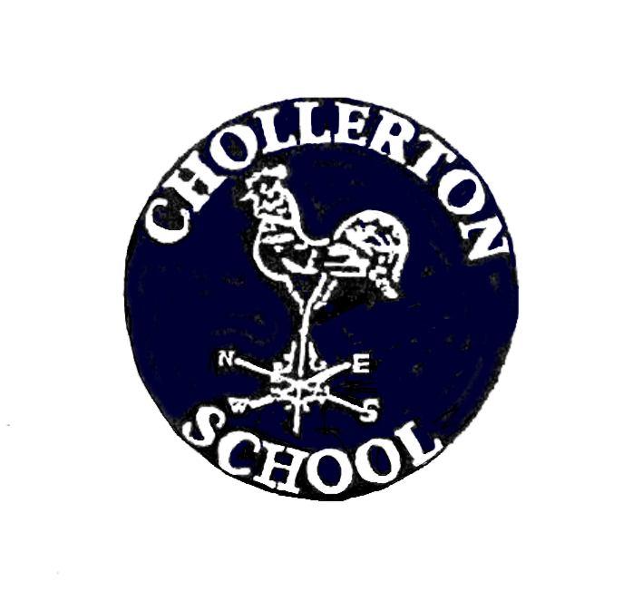
CHOLLERTON C of E AIDED FIRST SCHOOL
Be the best you can be through:
challenge, nurture, inspiration, respect, happiness, inclusion, in a safe, loving Christian family.

This is Chollerton C of E First School’s Publication Scheme
on information available under the Freedom of Information Act 2000

The Governing Body is responsible for maintenance of this scheme.

- Introduction: what a publication scheme is and why it has been
Developed

One of the aims of the Freedom of Information Act 2000 (which is referred to as FOAI in the rest of this document) is that public authorities, including all maintained schools, should be clear and proactive about the information they will make public.

To do this we must produce a publication scheme, setting out:
- The classes of information which we publish or intend to publish;
- The manner in which the information will be published; and
- Whether the information is available free of charge or on payment.

The scheme covers information already published and information which is to be published in the future. All information in our publication scheme is available in paper form.

Some information which we hold may not be made public, for example, personal information.

This publication scheme conforms to the model scheme for schools approved by the Information Commissioner.

2. Aims and Objectives

The school aims to:
- Enable every child to fulfil their learning potential, with education that meets the needs of each child;
- Help every child develop the skills, knowledge and personal qualities needed for life and work.

This publication scheme is a means of showing how we are pursuing these aims.
3. Categories of information published

The publication scheme guides you to information which we currently publish (or have recently published) or which we will publish in the future. This is split into categories of information known as ‘classes’. These are contained in section 6 of this scheme.

The classes of information that we undertake to make available are organised into four broad topic areas:

- School Prospectus - information published in the school prospectus.
- Governors’ Documents - information published in the Governors Annual Report and in other governing body documents.
- Pupils & Curriculum - information about policies that relate to pupils and the school curriculum.
- School Policies and other information related to the school - information about policies that relate to the school in general.

4. How to request information

If you require a paper version of any of the documents within the scheme, please contact the school by telephone, email, fax or letter. Contact details are below .

Tel: 01434 681572

Fax: 01434 681572

Address:
Station Road
Barrasford
Hexham
Northumberland
NE48 4AA

To help us process your request quickly, please clearly mark any correspondence:
“PUBLICATION SCHEME REQUEST” (in CAPITALS please).

If the information you’re looking for isn’t available via the scheme you can still contact the school to ask if we have it.

5. Paying for information

Single copies of information covered by this publication are provided free unless stated otherwise in section 6. If your request means that we have to do a lot of photocopying or printing, or pay a large postage charge, or is for a priced item such as some printed publications or videos, we will let you know before fulfilling your request. Where there is a charge this will be indicated by a £ sign in the description box.
School policies and other information related to the school - This section gives access to information about policies that relate to the school in general.

Class | Description
Published reports of Ofsted referring expressly to the school | Published report of the last inspection of the school and the summary of the report and, where appropriate, inspection reports of religious education in those schools designated as having a religious character.
Post-Ofsted inspection action plan | A plan setting out the actions required following the last Ofsted inspection and, where appropriate, an action plan following inspection of religious education where the school is designated as having a religious character.
Charging and Remissions Policies | A statement of the school’s policy with respect to charges and remissions for any optional extra or board and lodging for which charges are permitted, for example, school publications, music tuition, trips.
School session times and term dates | Details of school session and dates of school terms and holidays
Health and Safety Policy and risk assessment | Statement of general policy with respect to health and safety at work of employees (and others) and the organisation and arrangements for carrying out the policy.
Complaints procedure | Statement of procedures for dealing with complaints
Performance Management of Staff | Statement of procedures adopted by the governing body relating to the performance management of staff and the annual report of the head teacher on the effectiveness of appraisal procedures.
Staff Conduct, Discipline and Grievance | Statement of procedure for regulating conduct and discipline of school staff and procedures by which staff may seek redress for grievance.
Curriculum circulars and statutory instruments | Any statutory instruments, departmental circulars and administrative memoranda sent by the Department of Education and Skills to the head teacher or governing body relating to the curriculum.
Annex A – Other documents | Annex A provides a list of other documents that are held by the school and are available on request.

7. Feedback and Complaints

We welcome any comments or suggestions you may have about the scheme. If you want to make any comments about this publication scheme or if you require further assistance or wish to make a complaint, then initially this should be addressed to
Mrs Hazel Davey, Headteacher,
Chollerton C of E First School,
Station Road,
Barrasford,
Hexham,
Northumberland,
NE48 4AA.
Tel: 01434 681572.

If you are not satisfied with the assistance that you get or if we have not been able to resolve your complaint and you feel that a formal complaint needs to be made, then this should be addressed to the Information Commissioner’s Office.

This is the organisation that ensures compliance with the Freedom of Information Act 2000 and that deals with formal complaints. They can be contacted at:
Information Commissioner, Wycliffe House, Water Lane, Wilmslow, Cheshire, SK9 5AF.
Or Enquiry/information line: 01625 545 700
E-mail: publications@ic-foi.demon.co.uk.
Website: www.informationcommissioner.gov.uk.

Date approved by the Governing Body:

Signed by -

..................................................

Reviewed: Autumn 2021
Date of next review: Autumn 2023

