CHOLLERTON CHURCH OF ENGLAND AIDED FIRST SCHOOL

Be the best you can be through:
challenge, nurture, inspiration, respect, happiness, inclusion, in a safe, loving Christian family.
ADMISSIONS POLICY 2024-2025

The Governing Body of Chollerton Voluntary Aided Church of England School is the Admissions Authority for the school and they intend to admit up to 10 pupils to the reception year group in September 2024-2025. This arrangement follows consultation between the governing body, the LA, all other schools in the area and all other Admission Authorities in the area.

Process
1. Applications for admission to the school should be made using the Local Authority Common Application Form by the national closing date of 15th January.

2. The Local Authority will inform parents of the offer of a place on behalf of the Governing Body on the national offer date 16th April or the next working day.

3. The Chollerton Church of England Aided First School has an admission number of 10 pupils for entry into Reception. The school will accordingly admit at least 10 each year if sufficient applications are received. All applicants will be admitted if 10 or fewer apply. Priority will then be given to those children who meet the criteria set out below.

The school is open to receive applications for admissions from the parents of all children. We must give priority to children in the care of local authority (looked after children) and those with special educational needs whose statement names the school. In the event of the number of applications exceeding the number of places available priority will be given to applications in the order of priority indicated below.

Admission arrangements to the Reception Year in September 2024
Parents wishing to apply for the Reception Year in September must complete the common application form provided by their home local authority (LA). This form must be completed even if your child attends our Early Years Unit or other school nursery /pre-school setting. The home LA is the LA in whose area the parents live at the time of the application. The form must be returned to that LA by the deadline.

Applications received after this date will normally only be considered after all those received on or before the cut-off date. Offers and refusals of places will be posted by the home LA.

Over-subscription Criteria
1. Looked After Children, Previously Looked After Children and Internationally Adopted Looked After Children (LAC, PLAC and IAPLAC)

Looked After Children, Previously Looked After Children and Internationally Adopted Looked After Children (LAC, PLAC and IAPLAC) The first oversubscription criterion must always be Looked After, Previously Looked After and Internationally Adopted Previously Looked After Children. As this is a legal requirement, it automatically appears as the first of the school's oversubscription criteria.

A “Looked After Child” (LAC) s a child who is (a) in the care of a local authority, or (b) being provided with accommodation by a local authority in the exercise of their social services functions (see the definition in Section 22(1) of the Children Act 1989) at the time of making an application to a school. A "Previously Looked After Child" (PLAC) is a child who was looked after but ceased to be so because they were adopted or became subject to a child arrangements order or special guardianship order immediately following having been looked after.

An "Internationally Adopted Previously Looked After Child (IAPLAC) is a child who appears (to the admission authority) to have been in state care outside of England and ceased to be in state care as a result of being adopted.

2. Children with a sibling at the school at the time when they would be admitted to the school

Siblings of pupils attending the school during the academic year to which the child would be admitted. ‘Sibling’ means a natural brother or sister, a half brother or sister, a legally adopted brother or sister or half-brother or sister, a step brother or sister, or other child living in the same household who, in any of these cases, will be living with them at the same address at the date of their entry to the school.

3. Regular attendance at public worship at St. Giles, Chollerton Church of England church, regular attendance at public worship in any Church of England church, or Attendance at public worship in any other Christian church.

Attendance will be established by information provided on the Supplementary Information Form completed by a member of the clergy or other designated church officer. For the purposes of these admission arrangements ‘regular’ means attendance at least eight times in the twelve months immediately prior to the date of application.

For the purposes of these admission arrangements 'other Christian church' means a church which is Designated under the Ecumenical Relations Measure 2018, nationally by the Archbishops of Canterbury and York, or locally by the diocesan bishop, or which is a member of Churches Together in England, or affiliated to the Evangelical Alliance or a Partner Church of Affinity. The list of nationally Designated churches can be found
at https://www.churchofengland.org/sites/default/files/2019-04/list_of_designated_churches_3_oct_18.pdf.

4. Distance from school

Proximity to the school with those living closest to the school having priority calculated by:
From the principal home address to its nearest to the school. Measured in a straight line, as the crow flies between the front door of the home and the main gate of school using the Local Authority’s computerised measuring system.

The child’s home address will be determined by:
The definition of 'home address' or 'principal', 'permanent' residence, for the purpose of school admissions, is the address at which your child resides most of the time.

5. Children living in the catchment area of the school.

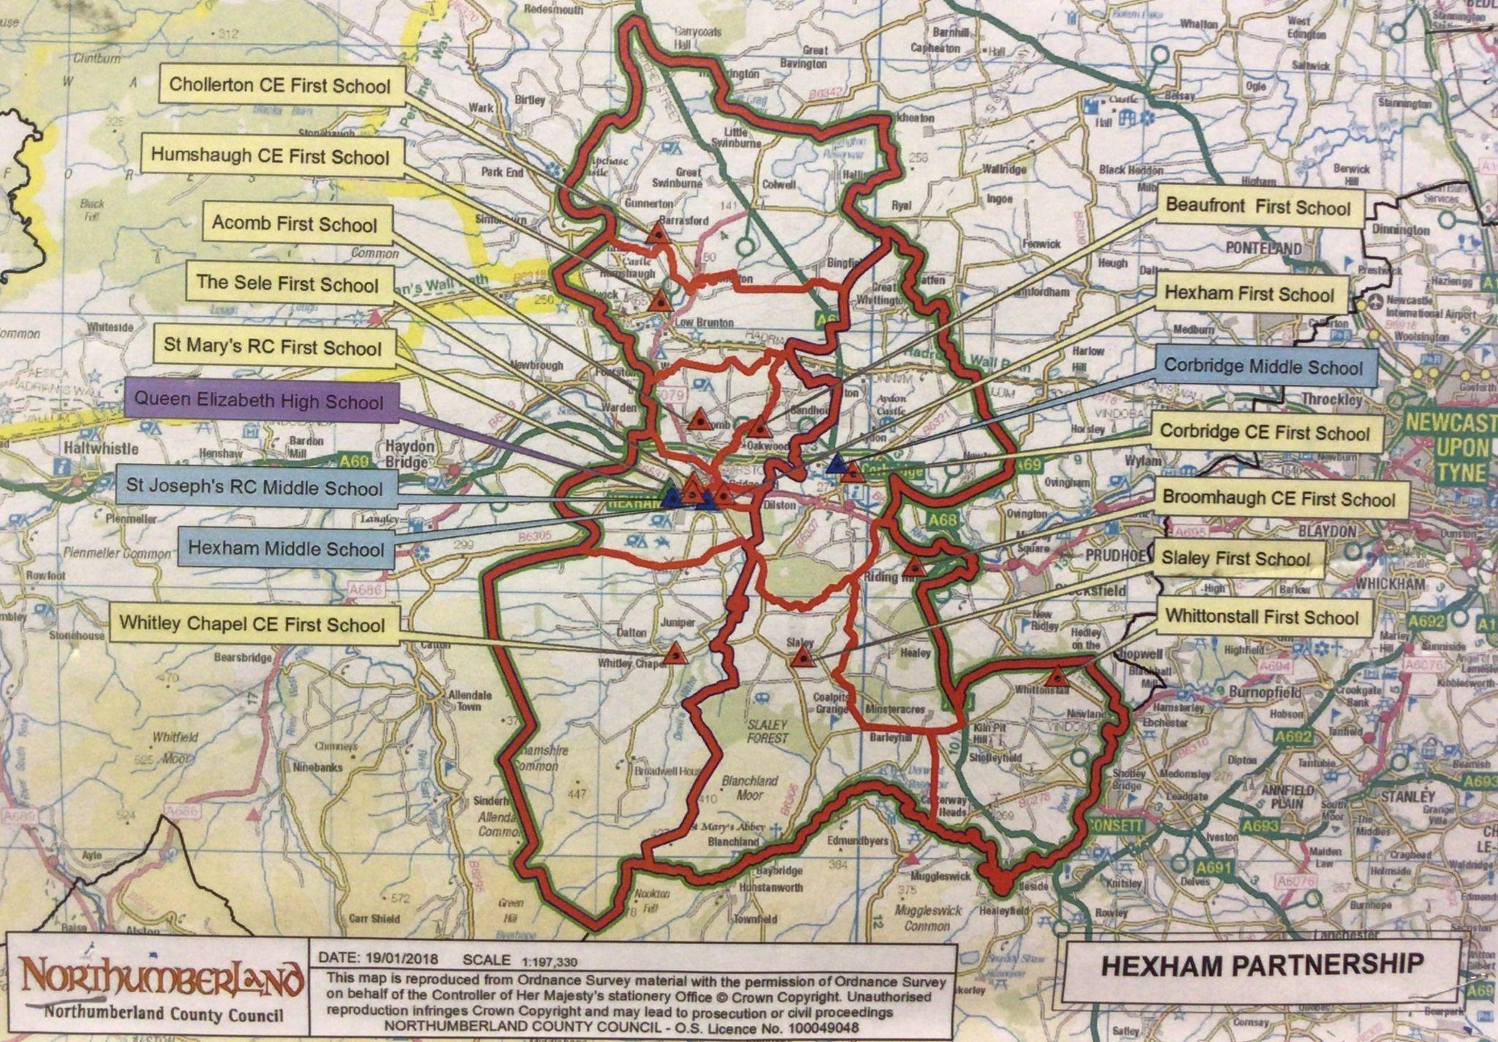

6. Children who have special medical needs or other special circumstances, (supported by medical/professional opinion).

Priority will be given in exceptional circumstances to a small number of children (or in some cases a close relative of the child) whose mental or physical impairment means they have a demonstrable and significant need to attend this school over any other.

Supporting evidence in the form of a letter from a doctor or social worker or other relevant qualified, independent professional, would be required. Medical, health, social and special access reasons will be applied in accordance with the school’s legal obligations and does not guarantee that a child will be given priority as each decision will be made on the merits of the individual case.

7. Pupil Premium

Children eligible for the pupil premium, including the service premium. Parents/guardians will be required to provide evidence of eligibility and the school may request confirmation from the applicant’s home local authority. Children given priority under this criterion fall into the following categories:

- Children eligible to be registered for free school meals and children who have been registered as eligible for free school meals at any point in the last six years; and
- Children whose parent(s) are serving in the regular UK armed forces, the children of regular armed forces personnel who were serving in the past 3 years, or children who are in receipt of a pension under the Armed Forces Compensation Scheme andthe War Pensions Scheme because their parent(s) died on active service with the UK armed forces.

8. Children of Staff

Children of all staff will be considered where the parent has a permanent contract of
employment and they were recruited to fill a vacant post for which there is a demonstrable skill shortage. Their normal base of work must be at Station Road, Barrasford, Hexham, Northumberland, NE48 4AA.

Children of all staff will be considered where the parent has a permanent contract of
employment. Their normal base of work must be at Station Road, Barrasford, Hexham,
Northumberland, NE48 4AA and their employment contract must have been in place for two or more years at the time of the closing date for application for admission.

Tie Breaker
Where there are places available for some but not all applicants within a particular criterion, distance from home to school will be the deciding factor, with preference given to those whose principal home address is nearest to the school, when measured in a straight line as the crow flies between the front door of the home and the main gate of school using the Local Authority’s computerised measuring system.

In the event that two or more children live at the same distance from the school (as can happen with families living in blocks of flats), random allocation, where supervised drawing of lots by an independent responsible person of good standing will be used to decide which child(ren) will be allocated the remaining place(s).

Late applications
Applications received after the closing date and before the Admissions Authority admission meeting will be placed last in the criteria in which they fall unless the Admissions Authority is satisfied that there are exceptional circumstances which reasonably prevented the application from being submitted on time. Supporting evidence, including that provided by the required Supplementary Information Form, must also be supplied by the closing date for applications, unless it is satisfied that there are exceptional circumstances which reasonably prevented it being submitted on time. In the absence of such supporting evidence, the allocation of places will be made on the basis of the application alone.

In-Year Admissions
Admission to the school during the school year depends on whether or not there are places available. Applications must be made through the LA, School Application Form. Guidance can be found on the Northumberland County Council Website. Admissions outside the normal age group will be dealt with as indicated below.

If there is a vacancy, and there is no child on the relevant waiting list with a higher priority a place will be offered.

In-year admissions or admissions at the beginning of school years other than Reception will only be considered by the Governing Body up to half a term [using the three-term year] in advance of the desired date for entry. For example, for entry in January, the application will not be considered until after the October half-term break.

Admission of children outside their normal age group
Parents may request that their child is admitted to a year group outside their normal age range, for instance where the child is gifted or talented or where a child has suffered from particular social or medical issues impacting on their schooling. All such requests will be considered on their merits and either agreed or refused, on that basis. If a request is refused, the child will still be considered for admission to their normal age group.

The process for requesting such an admission is as follows: With the application, parents should request that the child is admitted to another year group (state which one), and the reasons for that request. Parents will submit any evidence in support of their case with the application, for instance from a medical practitioner, headteacher etc. Some of the evidence a parent might submit could include:
- information about the child’s academic, social and emotional development;
- where relevant, their medical history and the views of a medical professional;
- whether they have previously been educated out of their normal age group; and
- whether they may naturally have fallen into a lower age group if it were not for
being born prematurely.

The school will consider each case on its merits, taking into account the individual
circumstances of the request and the child’s best interests. We will also ensure the parent is aware of whether the request for admission out of age group has been agreed before final offers are made, and the reason for any refusal. Requests for admission out of the normal year group will be considered alongside other applications made at the same time.

Waiting List
The school office will maintain a waiting list of applicants until 31 December in each year. In the event of a place becoming available in the appropriate class during the year and there are more applicants on the waiting list than places available, the selection criteria and tiebreaker indicated above will apply.

Multiple births
In cases where there is one place available and the next child on the list is a twin, triplet,
etc., we would admit both twins (and all the children in the case of other multiple births) even if this meant exceeding the agreed admission number for Reception or the number of places in other year groups in the relevant admission year.

Appeals Procedure
All applicants refused a place have a right of appeal to an independent appeal panel constituted and operated in accordance with the School Admission Appeals Code. Appellants should contact Hazel Davey at Chollerton Church of England Aided First School at Station Road, Barrasford, Hexham, Northumberland, NE48 4AA within 30 days of the date of the letter refusing your child a place at the school for information on how to appeal.

Notes
- Parents are asked to let the head teacher know if a place is offered whether their child has a disability. Parents should be assured that the nature of the disability is not grounds for refusing the application. The school will make every reasonable adjustment to ensure that disabled children are not put at a substantial disadvantage in accessing a full curriculum and that they will not be treated less favourably, without reasonable justification, than their able-bodied peers.
- Brother or sister, half brother or sister, adopted brother or sister, step-brother or sister, or the child of a parent’s/carer’s partner – in every case the child should be living in the same family unit at the same address.
- If applicants are seeking admission under the criterion of living in the Parish or worshipping regularly and frequently at a Parish Church as above, they will be asked to provide evidence that they worship regularly and frequently, e.g. a letter from the incumbent. Regularly and frequently is defined as attendance at least once per month over the last twelve months.

- A map showing the parish boundaries can be inspected at the school office.
- If applicants are seeking admission under the criterion of special medical needs or other special circumstances, they will be asked to provide appropriate evidence, e.g. a letter from a doctor or specialist. The governors must be satisfied that there is a specified medical reason which makes attendance at this school essential.
- Nursery admissions are entirely separate and parents are asked to note that attendance at the school’s nursery does not guarantee a place in the reception class.
- Parents who are refused a place have a statutory right of appeal. Further details of the appeals process are available by writing to the Chair of Governors at the school address.
- If a place is offered on the basis of false information (e.g. address or Church attendance) or if parents do not respond within the stated timescale to the offer of a place the governing body reserves the right to withdraw their offer.

Admission of children below compulsory school age and deferred entry to school
The School Admissions Code requires school admission authorities to provide for the admission of all children in the September following their fourth birthday. However, a child is not required to start school until they have reached compulsory school age following their fifth birthday. For summer-born children (those born after 1 April) this can sometimes be almost a full school year after the point at which they could first be admitted.

Some parents may feel that their child is not ready to start school in the September following their fourth birthday. Parents are entitled to request in writing that:-
- their child attends part-time until they reach compulsory school age, or
- that the date their child is admitted to school is deferred until later in the same academic year or until the term in which the child reaches compulsory school age.
- that the date their child is admitted to school is deferred until the term after the child reaches compulsory school age.

The child must, however, start school full-time in the term after their fifth birthday.

The school finds it very helpful to have an early indication of the number of children to be admitted to the reception class the following September. However, it must be stressed that formal written applications for admission must be made on the form provided and returned to the Local Authority by the stated date. Places will then be allocated by strict application of the above criteria, with no reference to the date of application. Parents will be notified as to whether or not their children have been successful in gaining a place by the end of April 2023.

Date approved by the Governing Body:
Signed by -
.................................................

This policy was reviewed: Autumn 2022
Date of next review: Autumn 2023

