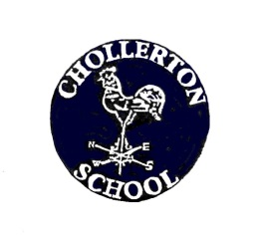
CHOLLERTON C of E AIDED FIRST SCHOOL
Be the best you can be through:
challenge, nurture, inspiration, respect, happiness, inclusion, in a safe, loving Christian family.
SEN Complaints Procedure

How should complaints regarding SEN provision be made and how will they be dealt with?

Concerns or complaints raised by parents are normally dealt with directly through telephone calls or interviews with the SENCO or Headtecher. Concerns that cannot be resolved in this way will follow a line of referral to the school’s Governing Body.

When necessary, parents will be supported in taking concerns to the Local Education Authority and fully informed of SEN Disagreement Resolution Procedures and SEN Tribunal Procedures.

Information regarding external support groups, such as Parent Partnership, will also be made available.

How may my child be supported?

If your child continues to have difficulties even with this extra support, we will, in consultation with you seek further professional advice. This is part of a multi- agency approach which sometimes includes completing the Early Health Assessment (EHA) to support the family as well as the pupil. During this meeting, we would discuss the needs of the individual child / family and plan together using information and guidance from parents / carers, school and other agencies.

Professionals who might attend this meeting include:

- A School Nurse who works closely with some children and advise and assess any medical needs
- An Educational Psychologist may work with your child. If so, any assessments and advice will be shared
- Behaviour Support Professionals may share information and strategies during the meeting
- Speech and Language Therapists
- Staff from feed preschool or nursery
- Specialist teachers in ASD
- Occupational Health Therapists
- Physiotherapist
- Hearing Impaired Teachers
- Visual Impairment Teachers
- Health Professionals
- Educational Professionals
- Specialist Teachers within the Local Inclusion Support Team (LIST)
- Guidance from Children and Young People Services (CYPS)
- Colleagues within the Northumberland Health and Well-being team
- If a care plan is required this would be completed together and reviewed annually as a minimum

Date approved by the Governing Body:
Signed by - ..................................................
This policy was reviewed: Autumn 2021
Date of next review: Autumn 2022

