Welcome to Reception!
2022 - 2023
Welcome to Chollerton First School’s Reception Class

Starting school is a very important time for the children as well as for their parents. We work hard to ensure that we provide a welcoming, happy and secure learning environment. Our aim is to develop the whole child by providing a broad play based curriculum which is appropriate to the age of the children, which meets individual needs and above all is fun!

In Reception, the children will be taught by Mrs Davey. On a Tuesday afternoon Mrs Ellison will teach the class and on a Thursday afternoon Mrs Hewitt teaches the class while Mrs Davey has time to complete her management commitments and PPA time.

Georgina Ritson and Fritha Valistar will be our teaching assistants for the class.

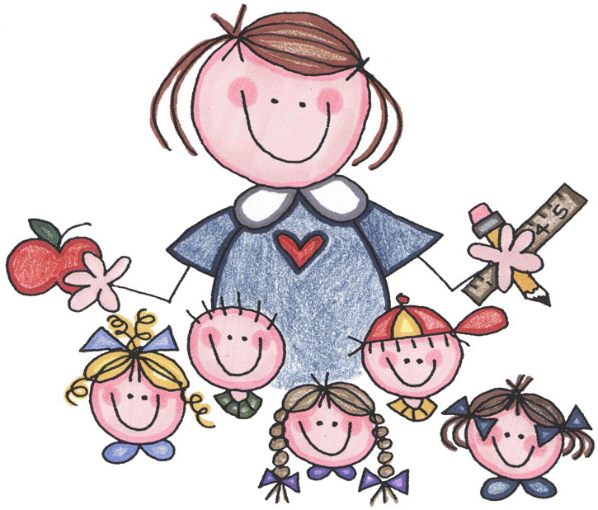

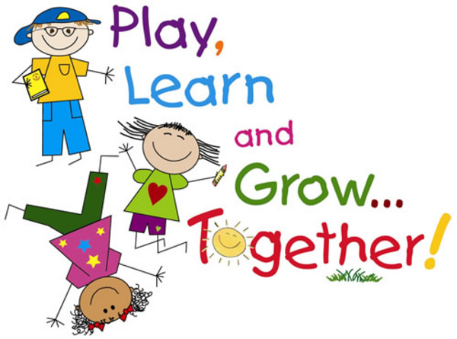
The Curriculum

In Reception we use ‘The Early Years Foundation Stage’ for planning and assessment which is followed in all early years settings. During the year the children will be working to meet the Early Learning Goals across the seven areas of learning.

Play and exploration is fundamental to our Reception class. It means that the children are able to choose activities where they can engage with other children, adults or sometimes play alone. During these activities the children will learn by first-hand experiences; by actively ‘doing’ as well as through scaffolding and modelling by adults. There will be a wide variety of planned and prepared activities by the adults as well as allowing time for the children to initiate their own learning. Activities will be planned through discussion with the children around their current interests, as well as taking into account their learning styles and stages of development.

The Learning Environment

The classroom is organised into different areas for the children to explore as they wish each day. We encourage the children to be independent learners and having the classroom organised with access to resources supports this approach. Our outdoor environment is an extension of the indoor classroom and is available for the children to use.

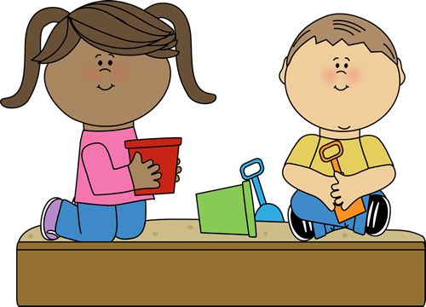

The Seven Areas of Learning

Personal, Social and Emotional Development
This very important area covers self confidence and positive attitudes to learning as well as the ability to get on well with others and to concentrate and persist with an activity. We have weekly circle times which allow the children to express their needs and feelings and to work together and help each other.
By the end of the Foundation Stage, most children will be able to:
- Play co-operatively, taking turns with others. They take account of one another’s ideas about how to organise their activity. They show sensitivity to others needs and feelings, and form positive relationships with adults and other children.
- Be confident to try new activities, and say why they like some activities more than others. They are confident to speak in a familiar group, will talk about their ideas and will chose the resources they need for their chosen activities. They say when they do or do not need help.
- Talk about how they and others show feelings, talk about their own and others behaviour and its consequences, and know that some behaviour is unacceptable. They work as part of a group or class and understand and follow the rules. They adjust their behaviour to different situations, and take changes of routine in their stride.
How can I help at home with personal, social and emotional development?
- Show a real interest in your child’s play and conversations.
- Praise your child for all effort no matter what the end result might be!
- Play together and show your child how much fun you are having.
- Encourage your child to try a bit harder or do a bit more each time.
- Play simple board games as a family so that your child learns to take turns and share and so that winning is not always the outcome but the fun of playing becomes more important.
- Enable your child to mix with other children by having a friend to play or by going to the park.
- Develop in your child an understanding approach towards other people and their needs by choosing story books which represent other cultures and lifestyles.



Communication and Language
This area covers speaking and listening. Speaking and listening are essential skills which affect all areas of learning. We help the children to extend their vocabulary and teach them to express their ideas clearly. Each week there are lots of opportunities for small group and whole class discussions/circle times. All the adults in the class will constantly be modelling good use of language, and supporting the children to talk about what they are doing, and why.

By the end of the Foundation Stage, most children will be able to:
- Listen attentively in a range of situations. They listen to stories, accurately anticipating key events and respond to what they hear with relevant comments, questions or actions. They give their attention to what others say and respond appropriately.
- Children follow instructions involving several ideas or actions. They answer ‘how’ and ‘why’ questions about their experiences and responds to stories or events.
- Express themselves effectively, showing awareness of listeners needs. They use past, present and future forms accurately when talking about events that have happened or are to happen in the future. They develop their own narratives and explanations by connecting ideas or events.

How can I help at home with communication and language development?
- Talk with your child explaining events and activities involving him/her in family discussion and decisions.
- Listen to what your child has to say and show a real interest.
- Introduce your child to a range of stories, rhymes and songs as well as making sure you read together daily.
- Use reference books together to help answer your child’s questions – children are fascinated by facts.
- Make up stories with your child and get involved in imaginative games together suggesting ideas or offering items to create a setting.
- Help your child to listen to the sounds in words in particular the first and last sound.
- Play games on journeys thinking of words that start with a chosen sound.
- Distinguish between the sound that a letter makes and its name.

Physical Development

The area of physical development is about improving the skills of co-ordination, control, manipulation and movement. It includes ‘gross’ physical skills like running, jumping and climbing as well as ‘fine’ skills such as pencil or brush control, using scissors or joining pieces of construction kits. We have PE sessions to develop gross motor skills. During this area of learning we will help the children to become aware of how to be healthy and to look after our bodies.

By the end of the Foundation Stage, most children will be able to:
- Show good control and coordination in large and small movements. They move confidently in a range of ways, safely negotiating space. They handle equipment and tools effectively, including pencils for writing.
- Know the importance of physical exercise, and a healthy diet, and talk about ways to keep healthy and safe. They manage their own basic hygiene and personal needs successfully, including dressing and going to the toilet independently.

How can I help at home with physical development?
- Provide a few basic outdoor toys – a plank and two boxes are ideal for balancing, over and under games, jumping and a range of imaginative games.
- Ensure that you discuss your child’s activity so that he/she develops the ability to describe what he/she is doing.
- Let your child have a place to freely use pens, paints etc. Whilst such activities may be messy, careful preparation by you and some clear instructions will allow your child to have valuable opportunities to experiment and create.
- Give your child old cards, catalogues and scissors. Your child will enjoy making birthday cards for relatives and friends and vital early skills will be practised in a fun way.
- Simple fun can be had with pastry and a few cutters, or a handful of nuts and bolts or different sizes, or empty food boxes and sticky tape, or a few kitchen containers and a bowl full of water!
- Encourage simple exercise such as walking or swimming and discuss the need to keep active.
- Offer healthy snacks and involve your child in shopping by planning meals together and making shopping lists in categories of food.

Literacy

In our school we use Twinkl Phonics which is a highly structured programme to enable the children to acquire the phonic knowledge and strategies they need for reading and writing. The children will be assessed during their first term at school. This allows the children to learn the skills at a level which is right for them.

In our learning environment there is a writing area and a book area and we promote and encourage reading and writing skills in all areas of the classroom and outside area. The children will learn to write using a range of tools and for a range of purposes. In our outdoor area we do writing and mark making on a bigger scale, for example using chalk, water and brushes and squeezy bottles.

There is a role play area inside and outside which is fundamental in helping the children to develop communication skills. Role play also supports the children in acquiring new vocabulary and writing skills in a purposeful way.

By the end of the Foundation Stage, most children will be able to:
Reading
- Read and understand simple sentences. They use phonic knowledge to decode regular words and read them aloud accurately; they also read some common irregular words. They demonstrate understanding when talking with others about what they have read.
Writing
- Use their phonic knowledge to write words in ways which match their spoken sounds. They also write some irregular common words. They write simple sentences which can be read by themselves and other. Some words are spelt correctly and others are phonetically plausible.

How can I help at home with literacy (reading and writing)?
- Share books with your child. It could be a favourite book or a book from the library. Look at fiction and non-fiction books.
- Practise holding and using a book correctly – tracking the text with your finger left to right, holding the book correctly and turning the pages in order, point out the title, blurb, author and illustrator.
- Talk about what is happening in a book, what is the book about, what could happen next?
- Have different words around the house for your child to go and find. Make it into a fun game!
- Help your child learn their letter sounds and to blend them to read the words.
- Help your child to sound out words to spell words and how to hold a pencil with the tripod hold and to form all the letter shapes correctly.
- Let your child have free access to paper, pencils and crayons so your child can practise writing when he/she wants to.
- Encourage your child to write in lower case letters, not capitals except for the start of a sentence or the beginning of a name.

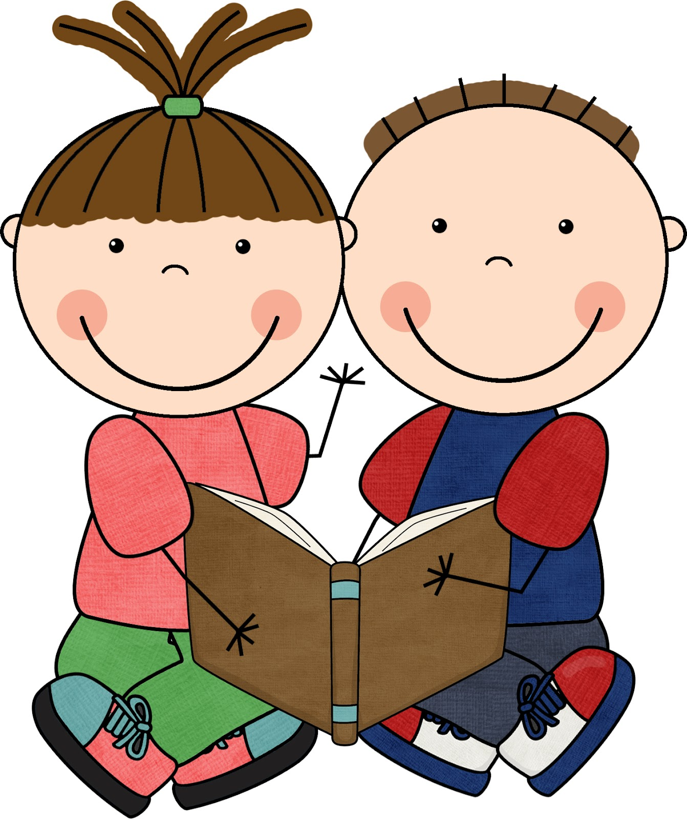

Mathematical Development

This area of learning includes counting, sorting, matching, recognising patterns and relationships and working with numbers, shapes, space and measures. Activities are practical and interesting for example the children might be building with 3D shapes or knocking down skittles of different values and calculating their score.

By the end of the Foundation Stage, most children will be able to:
- Count reliably with numbers 1 to 20, place them in order and say which number is one more or one less than a given number. Using quantities and objects they add and subtract two single digit numbers and count on or back to find the answer. They solve problems including doubling, halving and sharing.
- Use everyday language to talk about size, weight, capacity, position, distance, time and money to compare qualities and objects and to solve problems. They explore characteristics of everyday objects and shapes and use mathematical language.

How can I help at home with mathematics?
- Be aware of the language you use and help your child to notice similarities and differences and to make comparisons.
- Be aware of the way that numbers features in our everyday lives and involve your child by talking about and reading door numbers, telephone numbers, prices at the shops, car number plates etc.
- Count routinely whenever you can. For example stairs in shops, red cars passing by, apples into a bag etc.
- Find ways to let your child practise his/her number skills by asking him/her to fetch 4 forks, count out coins etc.
- Let your child write numbers and draw shapes (the bathroom tiles can be great fun to write on with soapy fingers at bath time).
- Encourage your child to add numbers to give detail to drawings. For example can you give your car a number plate, a house needs a door number.
- Give your child empty packets to play a shopping game and give real coins or realistic plastic ones to develop the ability to add numbers together.
- Test each other by playing maths games on journeys. - For example, what number comes after 5? How many times did I clap? Which animal is bigger than a cat?

Understanding the World
In this area of learning children are developing the important knowledge, skills and understanding that helps them make sense of the world. We provide opportunities to solve problems, make decisions, experiment, predict, plan and question in a variety of contexts and to explore and find out about their environment and people and places that have significance in their lives.

ICT skills are developed through the provision of appropriate software and all children have many opportunities to use simple technology.

By the end of the Foundation Stage, most children will be able
- Talk about past and present family events in their own lives and in the lives of family members. They know that children don’t always enjoy the same things, and are sensitive to this. They know about similarities and differences between themselves and others, and among families, communities and traditions.

- Know about similarities and differences in relation to places, materials and living things. They talk about the features of their immediate environment and how environments might vary from one another. They make observations of animals and plants and explain why some things occur, and talk about changes.
- Recognise that a range of technology is used in places such as homes and schools. They select and use technology for particular purposes.

How can I help at home with understanding the world?
- It is important to realise that children only learn if they are interested and that nurturing interest will ensure that your child becomes a motivated life-long learner.
- Give your child safe opportunities to explore and discover:
    - A section of garden for him/her to dig.
    - A box of photographs to browse through.
    - A magnifying glass to look through.
    - A family walk or outing where you can talk about what you see and do in the world.
- Introduce your child to elements of other cultures in a positive way so that he/she realises that other people live their lives differently.
- Talk about your childhood or that of an older relative highlighting events and changes.
- Make sure you show an interest in the world too – children pick up on other peoples’ enthusiasm!
- Learn and make new discoveries together.

Expressive Arts and Design
This area includes art, music, dance, role play and imaginative play. The role play areas are changed regularly to fit in with current topics and to stimulate the children’s imagination. The children have the opportunities to work with a wide range of resources to create 2D and 3D art work. We use percussion instruments to accompany recorded music and songs and to explore rhythm and express emotion. We encourage your child to move to music and to act out favourite stories.

By the end of the Foundation Stage, most children will be able
- Sing songs, make music and dance, and experiment with ways of changing them. They safely use and explore a variety of materials, tools and techniques, experimenting with colour, design, texture, form and function.
- Use what they have learnt about media and materials in original ways, thinking about uses and purposes. They represent own ideas, thoughts and feelings through design and technology, art, music, dance, role play and stories.

How can I help at home with expressive arts and design?
- Help your child to experience the world through his/her senses, encouraging him/her to see, hear, smell, touch and feel.
- Play a variety of music at home talking about who wrote it and when and encouraging your child to dance, clap or sing along.
- Let your child have simple items for music making such as lids, spoons and pots filled with rice.
- Sing around the house making up words to suit the occasion!
- Talk about feeling in relation to music choosing gentle music when your child needs to relax and lively pop songs when he/she has energy to release.
- Find a place in your home or garden where your child can use paint, clay, glue etc.
- Demonstrate to your child such as knitting, woodwork or playing a guitar to raise your child’s awareness of creative ability and possibly develop early skills in your child.

Assessments

The children will be assessed at the beginning of their Reception Year. The results will be shared with you.
The children will be observed during their time in Reception and the way they are effective learners will be reported to you.

You will have the opportunity to discuss progress with Mrs Davey after the first half term.

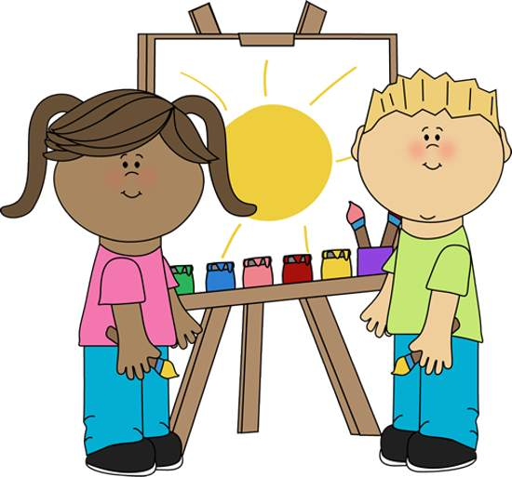
Partnership with Parents

We believe that our children’s best interests will be met when we work in partnership with parents. We welcome parents into our school and greatly value their support and practical help.

We keep parents involved with a weekly class diary which provides information about what we are learning about. Parents’ evenings are held in October and February and parents receive a detailed written report on their child’s achievements at the end of the year.

Contributions to your child’s diary give us an insight into your child’s interests.

We also have workshops throughout the year where parents and carers are invited in to school to find out what we do in school and how these activities can be used in school.

We have our own webpage on the school website where we keep parents/carers informed about what we are doing as well as photographs of activities and events we have been involved in.
www.chollerton.northumberland.sch.uk

We set the children challenges to complete at home related to the topic we are learning about. These can be found on our topic overviews which we send home each term and also put on our webpage.

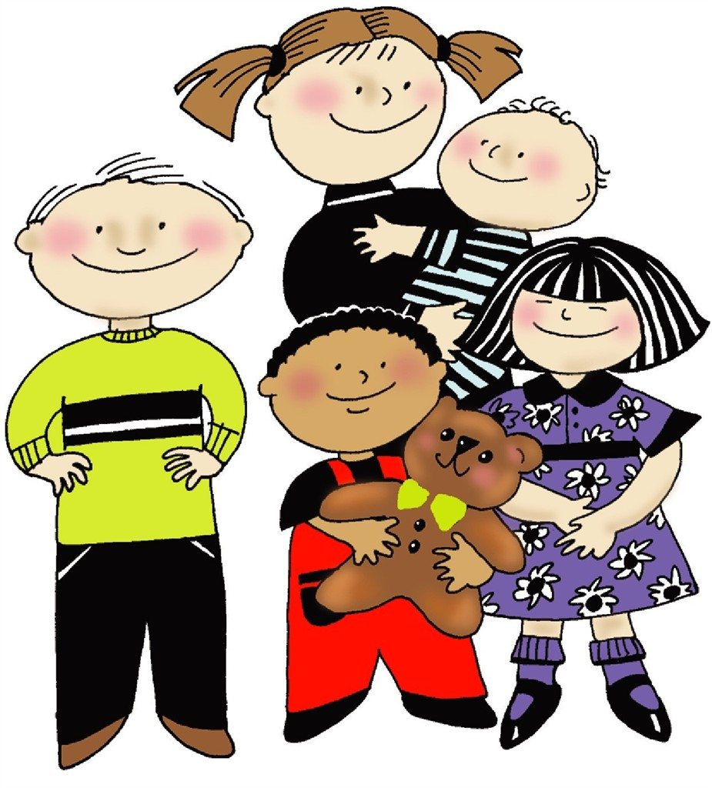

The School Day

- School starts at 8.55am
- Morning Snack is at 10.30am
- Morning Playtime: 10.45 – 11.00am
- Lunch is 12.00 – 13.00pm
- End of School Day: 3.15pm

Children should be collected at the school gates.
Please inform a member of staff if it is not the usual person collecting your child at the end of the day. If we have not been told who is picking them up we will not let them go without checking.

If your child is unwell please telephone school before 8.55am to inform us of their absence.
If your child uses school transport please call the bus company and inform them of the absence.

Reading Books

All the children will be bringing reading books home to share with you. They will have a home-school reading diary for you to record which books your child has read. If you have any comments you would like to make about your child’s reading please use this book. Staff will hear your child read and change their reading book regularly.

Each week all the children will take part in a Guided Reading. During these sessions the children will be taught basic book skills and taught how to decode unknown words.

We will also send home flashcards and letter sound cards for you to practise with your child on a regular basis.

Lunches

Children in Reception, Year 1 and Year 2 will receive a free school meal.
Years 3 & 4 pupils will pay £2.30 per day.
Children can bring a packed lunch to school if they wish.

Milk is free for children who are under 5 for the whole term. Other children will be charged approximately 25p per day.

Water bottles and snacks
We will provide your child with a water bottle and will fill it up each day. Children learn best when they are well hydrated! If their water bottle becomes empty we can easily fill it up in the classroom.

We have a healthy snack each morning.
We will ask for a small contribution to help with the cost of this.

.
Clothing

We would like all children to wear our school sweatshirt which can be ordered from the School Trends.

Please make sure that all your children’s clothing is clearly named. Their PE kits; shorts, t-shirts plimsolls should also be labelled. Your child’s PE kit will be kept in their bag on their peg in the cloakroom and should be taken home on a half-termly basis for washing.

Swimming

All the children will have weekly swimming lessons at the Wentworth Leisure Centre, throughout the second half of the spring term, and the full summer term.
Children will need to bring in a swimming costume/trunks (no bikinis or baggy shorts) and a towel in a bag on a Monday morning.
Long hair should be tied back for the lesson.
Lessons will cost £4.00 per week.



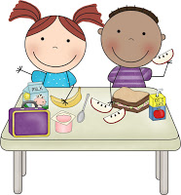
Preparing your child for school

It will really help the children and us if they are able to do the following things at home to complement our work in school:
- Dress and undress independently including doing up their own coat and shoes.
- Help to tidy up.
- Use the toilet and wash their hands independently.
- Use a knife and fork.
- Spend time sharing books.
- Talk about everyday things.
- Ask questions and be observant.


And finally…..

We are really looking forward to welcoming you and your child to Chollerton First School this year. We like to develop our curriculum throughout the year with ideas suggested by children.

We are really looking forward to working with the children during the first year of their school life.

We hope the information in the booklet is useful and answers many of your questions. If you have any more questions then please come and see any member of staff. We also understand that many parents work and are not always able to see staff about any questions or concerns that they might have about their child. Please don’t hesitate to telephone school and we will do all we can to help.

Here’s to a fantastic Reception Class this Year!

